Brett Stelly

Cameras and Projections

**Camera class used by CameraApplication class**

In order for my CameraApplication class to use the Camera class, I first declare a variable of type Camera* in the CameraApplication class header file and I initialize it with a new Camera.



In the CameraApplication’s startup function, I call Gizmos create function. Then, I set the camera’s viewTransform member variable by calling setLookAt. Next, I set the camera’s projectionView member variable by calling SetPerspective.

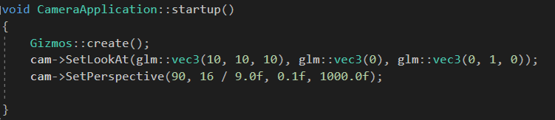

In order to actually see through the camera, I call Gizmos’ draw function and give it the Camera object’s, projectionTransform, viewTransform, and worldTransform.

